Ean Masoner Module 7.2 Assignment

City_Function.py Screenshot

First run of tes_cities.py screenshot

Fail test_cities

Second run of test cities.py

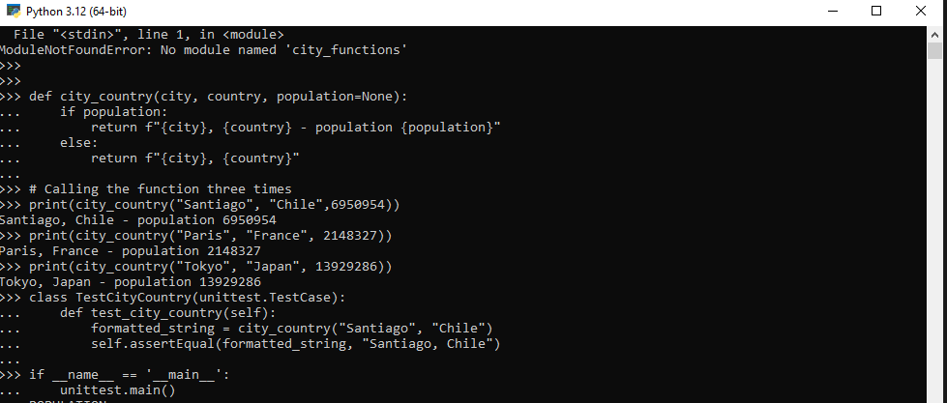

2nd Fail test cities.py

Final run run of test cities py

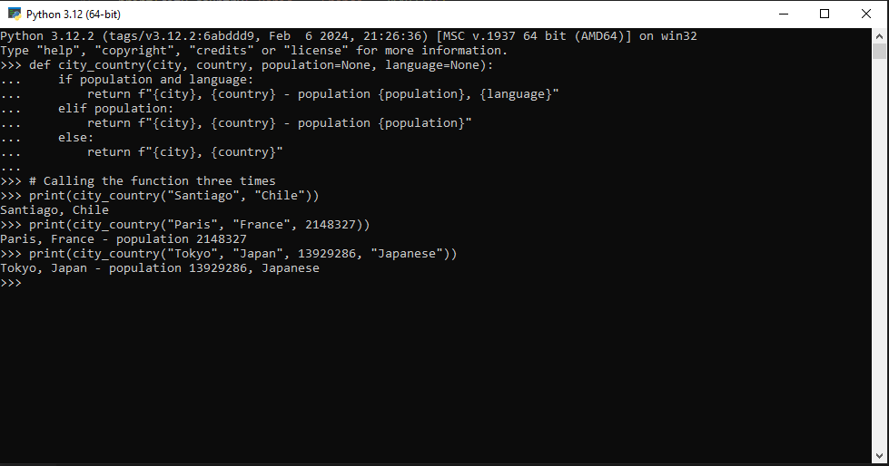

Fail of final run

